Perran-ar-worthal

Local History Group

**AGM**

**Tues 6th May 7.30pm**

**at the Perranwell Centre**

After the main business this will be a social event with drinks and nibbles provided

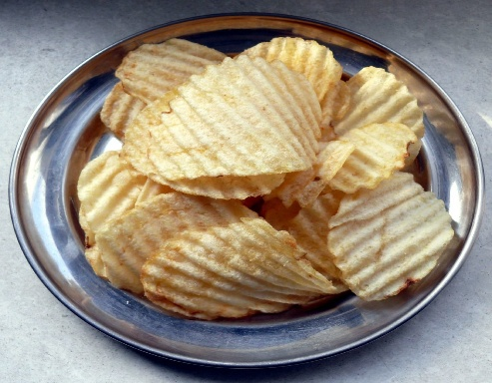

[This Photo](https://www.flickr.com/photos/46315235@N00/439566082/) by Unknown Author is licensed under [CC BY-NC-ND](https://creativecommons.org/licenses/by-nc-nd/3.0/)

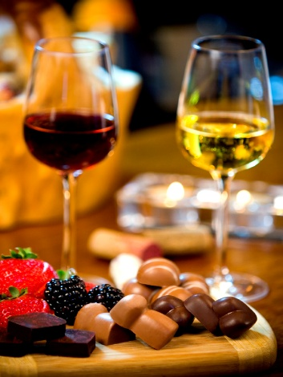

[This Photo](https://www.sergetheconcierge.com/2011/week41/) by Unknown Author is licensed under [CC BY-NC-ND](https://creativecommons.org/licenses/by-nc-nd/3.0/)

*We are interested to hear your ideas for future events.*

There will be an opportunity to renew your annual membership which is still only £6

*Please do bring along an item or story of historic interest to tell us about if you can….*

